# 1. Team

**Intelligent Study Companion Creation Tool**

**Team Name: Study Buddy Developers**

#### Team Logo:



**Team Members:**

1. **[Metta Rohith,** Team Leader, [2320030203@klh.edu.in]](mailto:2320030203@klh.edu.in])
2. **[K. Mokshagna,** Code Developer**,** [**2320030252@klh.edu.in**](mailto:2320030252@klh.edu.in)**]**
3. [**K. Bhargav**, Code Developer, [2320030256@klh.edu.in](mailto:2320030256@klh.edu.in)]
4. [**P. Venkata Sai**, Code Developer, 2320030219@klh.edu.in]
5. [**Ashrith**, Code Developer, 2320030460@klh.edu.in]

# Problem/Opportunity Domain

## Domain of Interest:

The domain of interest for your Intelligent Study Companion Creation Tool falls within the **education technology (EdTech)** industry. This field focuses on leveraging technology to enhance teaching and learning experiences. Your tool specifically addresses student needs by improving study methods, facilitating personalized learning, and utilizing AI for educational content generation. This innovation can be applied in various educational settings, from K-12 schools to higher education institutions, and even for lifelong learners seeking to enhance their study practices.

## Description of the Domain:

The EdTech domain encompasses a variety of technologies aimed at enhancing education, including learning management systems, adaptive learning tools, assessment technologies, and content creation applications. Key elements focus on providing personalized learning experiences, interactive content, and data analytics to support both students and educators. However, the domain faces several challenges, such as the digital divide that can leave some students behind, difficulties in maintaining engagement in digital environments, the need for high-quality content, and concerns over privacy and security.

## Why did you choose this domain?:

I chose the EdTech domain for several compelling reasons. Firstly, I have a passion for education and believe in its transformative power. I am motivated by the potential to enhance learning experiences and make education more accessible and engaging for students of all backgrounds. Additionally, the market potential in EdTech is significant; the demand for innovative learning solutions continues to grow, especially as more institutions adopt technology-driven approaches.

# Problem/Opportunity Statement

## Problem Statement:

The problem at hand is the challenge students face in effectively retaining information and preparing for examinations in a structured and engaging manner. Traditional study methods, such as passive reading and rote memorization, often lead to poor retention and lack of engagement, resulting in anxiety and suboptimal academic performance.

As educational demands increase, students require more effective tools to help them assimilate and recall information. The reliance on generic study aids can be insufficient, as they often do not cater to individual learning styles or specific subject matter.

## Problem Description:

The issue at hand is that many students struggle to effectively retain and recall information when preparing for exams. Traditional study methods, such as reading notes or textbooks, often fail to engage students actively, leading to inadequate comprehension and poor retention. Additionally, existing study aids are frequently generic and do not address individual learning needs or specific subject matter.

## Context (When does the problem occur):

The problem of ineffective information retention and study preparation arises in several specific contexts. During exam preparation periods, such as midterms and finals, students often face heightened stress as they attempt to assimilate large volumes of information in a limited timeframe, leading to cramming that is less effective for long-term retention.

Additionally, in diverse learning environments, students with varying learning styles may struggle to keep pace with conventional teaching methods, resulting in disengagement and frustration. Self-directed learning, particularly in online or hybrid courses, presents its own challenges, as students may find it difficult to create effective study materials independently and often rely on outdated resources. This issue is further exacerbated in subjects with complex concepts, like science and mathematics, where deeper understanding is essential but difficult to achieve through passive study techniques.

## Alternatives (What does the customer do to fix the problem):

To address the challenges of ineffective study preparation and information retention, students currently employ several existing solutions and strategies. Many rely on traditional study methods, such as re-reading notes or textbooks, which often lead to superficial understanding. Some use generic flashcard apps to create digital flashcards, but these tools typically lack personalization and do not generate content based on specific study materials. Forming study groups is another common practice, allowing for collaborative reinforcement of knowledge, though it requires coordination and may not be effective if group members are at different levels of understanding.

## Customers (Who has the problem most often):

The primary group affected by the problem of ineffective study preparation and information retention includes a diverse range of individuals, primarily students. This encompasses elementary school learners, high school students preparing for college entrance exams, and university undergraduates and graduate students facing the pressures of extensive syllabi and exam preparation. High school students, in particular, experience significant stress during critical assessments, while college students often juggle multiple subjects, part-time jobs, and extracurricular activities, making personalized study solutions essential for effective learning.

## Emotional Impact (How does the customer feel):

The emotional impact on customers dealing with ineffective study preparation and information retention is significant and multifaceted. Students often experience heightened anxiety and stress, especially during exam periods, as they struggle to manage large volumes of material and fear poor performance. This anxiety can lead to feelings of inadequacy and self-doubt, diminishing their confidence in their abilities.

Frustration is another common emotion, as many students feel overwhelmed by the demands of their coursework and the ineffectiveness of traditional study methods. They may feel isolated when their peers seem to grasp concepts more easily or when they cannot find suitable resources that meet their specific needs. This sense of disconnection can exacerbate feelings of helplessness and discourage them from seeking help.

## Quantifiable Impact (What is the measurable impact):

The quantifiable impact of ineffective study preparation and information retention can be significant and manifests in various measurable ways. Poor retention often leads to lower grades, directly affecting students' GPAs and academic standing, which may result in missed scholarship opportunities and long-term financial implications. Additionally, students frequently spend excessive hours studying without achieving effective results, with research indicating that up to 25% of study time is wasted on ineffective methods. This inefficient use of time can also contribute to increased stress levels, leading to potential health care costs associated with stress-related issues like anxiety and depression, which in turn may cause missed classes and reduced academic engagement.

## Alternative Shortcomings (What are the disadvantages of the alternatives):

The current alternatives for addressing ineffective study preparation and information retention come with several limitations and downsides:

**Traditional Study Methods:** Passive techniques, such as re-reading notes or textbooks, often lead to superficial understanding and poor retention. These methods do not promote active engagement with the material, making it difficult for students to apply knowledge in real-world contexts.

**Generic Flashcard Apps:** While useful, many flashcard applications lack the ability to generate personalized content based on specific study materials or learning objectives. This one-size-fits-all approach may not address individual learning needs or cater to various subjects effectively.

**Any Video or Images to showcase the problem:**





# System Architecture

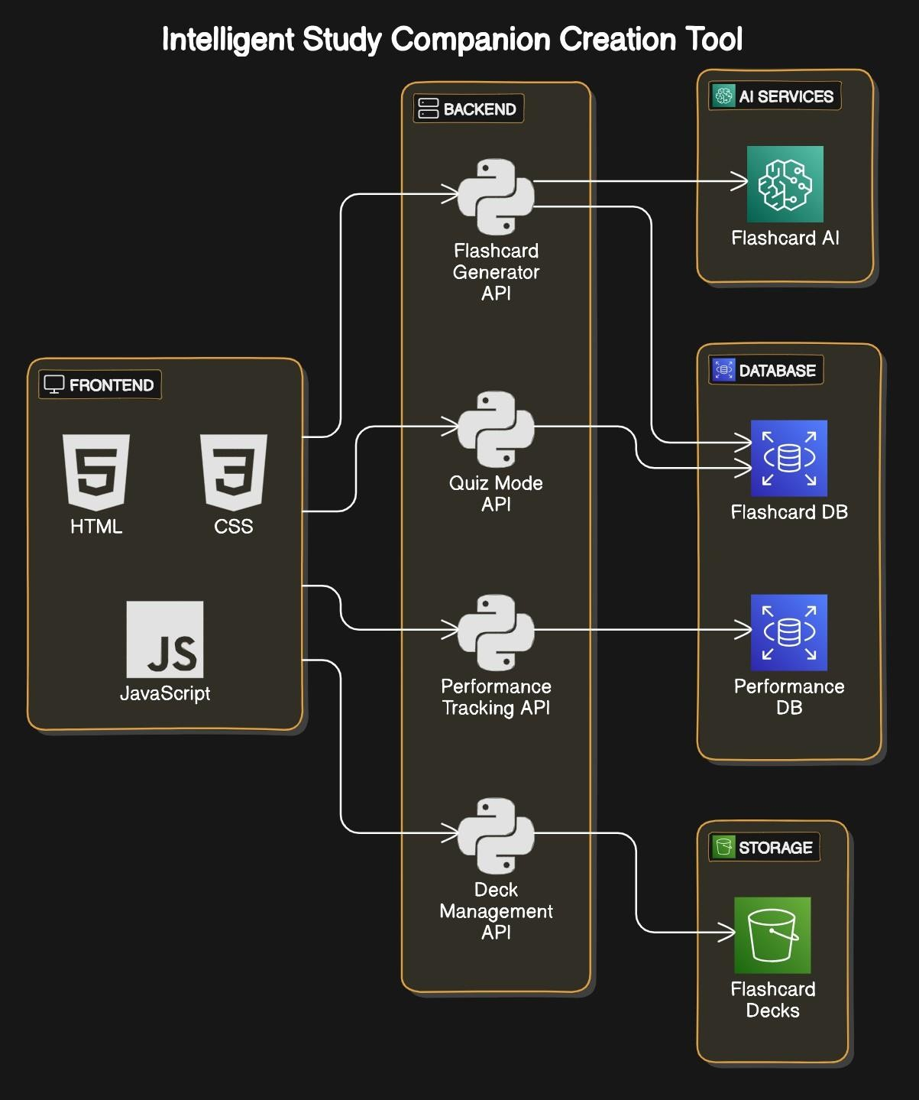

* 1. **Solution Concept Form**

#### Problem Statement:

Students face significant challenges in effectively retaining information and preparing for examinations, leading to increased anxiety and suboptimal academic performance. Traditional study methods, such as passive reading and generic study aids, often fail to engage students or cater to their individual learning needs. This results in inefficient study sessions, wasted time, and a lack of confidence in their abilities.

#### Target Audience:

1. **Students of All Educational Levels:** This encompasses elementary, high school, undergraduate, and graduate students who need effective study aids to help them retain information and prepare for exams.
2. **High School Students:** As they approach college entrance exams and final assessments, high school students often experience heightened stress and would benefit from personalized study tools that cater to their specific subjects and learning styles.

#### Solution Overview:

1. **Personalized Flashcard Generation:** Users can input notes or select specific topics, and the tool automatically generates relevant flashcards to aid in retention.
2. **Quiz Mode:** A built-in quiz feature allows students to test their knowledge and reinforce learning through active recall.



#### Key Features:

|  |  |
| --- | --- |
| **Feature** | **Description** |
| **Feature 1** | **Personalized Flashcard Generation:** Users can input their own notes or select specific topics, and the tool automatically generates relevant flashcards focusing on key concepts, questions, and answers, enhancing retention and understanding. |
| **Feature 2** | **Quiz Mode:** This feature enables students to engage in self-assessment through interactive quizzes based on the generated flashcards, promoting active recall and reinforcing knowledge in an engaging way. |
| **Feature 3** | **Progress Tracking:** The tool monitors user performance over time, identifying areas where students may need additional focus. This feature provides insights and analytics to help users optimize their study sessions and improve their learning strategies. |



* 1. **Benefits:**

|  |  |
| --- | --- |
| **Benefit** | **Description** |
| **Benefit 1** | **Enhanced Learning Efficiency:** The Intelligent Study Companion Creation Tool significantly improves study efficiency by providing personalized flashcards and quizzes, allowing students to focus on the most relevant information and retain it more effectively. |
| **Benefit 2** | **Active Engagement with Material:** By incorporating interactive elements like quizzes, the solution encourages active engagement with the study material, helping students to better understand and apply concepts rather than relying on passive study methods. |
| **Benefit 3** | **Tailored Learning Experience:** What sets this solution apart is its ability to generate customized study aids based on individual notes and learning preferences. This personalization not only caters to diverse learning styles but also helps to foster a deeper connection with the content, ultimately leading to improved academic outcomes. |



* 1. **Unique Value Proposition (UVP):**

The Intelligent Study Companion Creation Tool stands out as a uniquely personalized study aid that transforms traditional learning methods into an interactive and efficient experience.

Unlike generic study resources, this tool automatically generates tailored flashcards and quizzes based on students' specific notes and subject matter, catering to individual learning styles and needs. By promoting active engagement through interactive quizzes and providing insights through progress tracking, it not only enhances retention but also boosts confidence in students’ abilities. This tailored approach resonates deeply with the target audience, including students of all levels and educators, as it addresses the common pain points of anxiety and inefficiency in study preparation. Ultimately, the Intelligent Study Companion offers a dynamic solution that empowers learners to achieve their academic goals with greater ease and effectiveness.

#### Key Metrics:

|  |  |
| --- | --- |
| **Metric** | **Measurement** |
| **Metric 1** | **User Engagement Rate:** This measures the frequency and duration of tool usage, indicating how actively students engage with the flashcards and quizzes. A higher engagement rate suggests that the tool is effectively capturing users' interest and facilitating their study process. |
| **Metric 2** | **Improvement in Academic Performance:** This metric tracks changes in users' grades or test scores before and after using the tool. An increase in academic performance demonstrates the effectiveness of the study companion in enhancing information retention and comprehension. |



* 1. **Feasibility Assessment:**

1. **Resources:** The development of the tool can leverage existing technologies, such as natural language processing (NLP) and machine learning algorithms, to analyze user input and generate personalized content. These technologies are well-established and widely used in educational applications, ensuring access to the necessary expertise and tools.
2. **Timeframe:** A phased development approach can be implemented, allowing for the initial rollout of core features, such as flashcard generation and quiz functionality, within a reasonable timeline (e.g., 6-12 months). Subsequent enhancements, like advanced analytics and user feedback integration, can be iteratively added based on user needs and testing.



### 9. Next Steps:

1. **Market Research:** Conduct thorough market research to understand user needs, preferences, and existing solutions. Gather feedback from potential users (students, educators) to refine the tool’s features and functionality.
2. **Define Requirements:** Create a detailed list of functional and non-functional requirements for the tool, including user interface design, performance metrics, and specific features to prioritize based on user feedback.
3. **Prototype Development:** Develop a minimum viable product (MVP) that includes core functionalities, such as personalized flashcard generation and quiz mode. This will allow for initial testing and feedback.
4. **User Testing:** Conduct usability testing with a select group of students and educators to gather insights on user experience, effectiveness, and areas for improvement. Analyze the feedback to make necessary adjustments.